# Q1

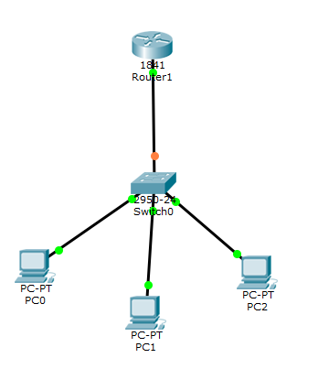

Enable and Configure Terminal Modes

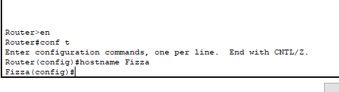

Clock Set command



Hostname Command

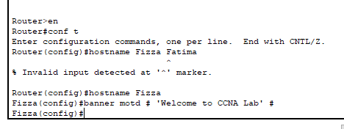

Setting Password

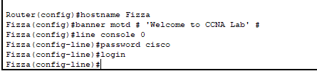

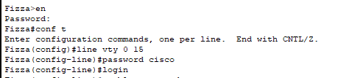

Logging Buffered Command

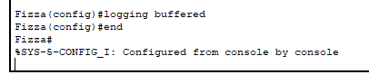

## **Final Outputs**

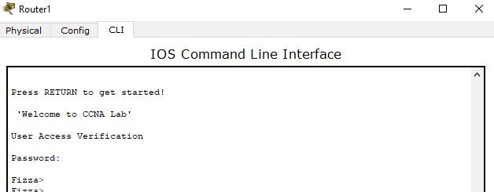

# Q2

## In user mode, one can view the configuration, links and ports of the device i.e. Switch or Router

## show mac-address-table

The command shows the mac address of the devices connected to the switch.

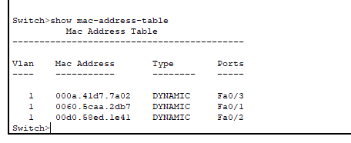

* show clock

It shows the current time

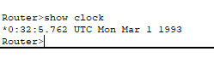

* show ip int brief

It shows the IP addresses of the interfaces.

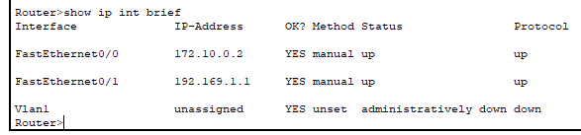

# Q3

## Commands of Privilege mode

* show running-config

It shows the current configuration/running devices or ports

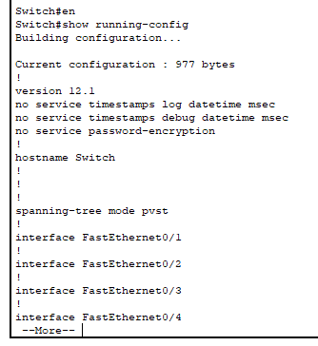

* show ip int brief

It shows ip address assigned against the ports

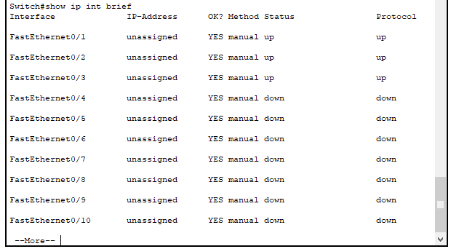

* show version

It shows the CISCO version

